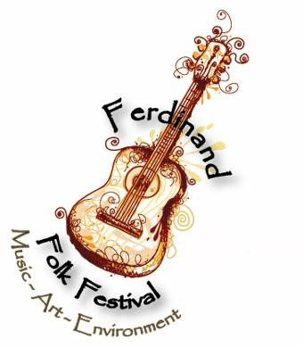

**Ferdinand Folk Festival 18th Street Park Ferdinand, Indiana**

**Saturday, September 17, 2022 Vendors open by 11:30 a.m. EST**

**Event is free to the general public. Visit** [**www.ferdinandfolkfestival.com**](http://www.ferdinandfolkfestival.com/)**.**

Dear Potential 2022 Vendor/Exhibitor:

The Ferdinand Folk Festival committee is pleased to announce the call for vendors/exhibitors for our eleventh annual Ferdinand Folk Festival on Saturday, September 17, 2022. ***Vendors***

***must be set up by 11:30 a.m. EST and closed at 6 p.m. EST.*** As in previous years, the festival will have a family-friendly, earth- friendly theme. We will have renowned, nationally-touring musicians, workshops, and wonderful activities for children. We also again welcome a vibrant diversity of art and food vendors and environmental/wellness education exhibits. **Because of overwhelming demand (increased volume of vendor/exhibitor requests) and limited space available, we are required to review and approve art products by a juried committee. Food vendors and environmental/wellness exhibitors will also need to be pre-approved. Due to tenure and their prior trust in vending with us, previous year(s) vendors will receive the first opportunity to apply—and be accepted—as a vendor at the Ferdinand Folk Festival.**

The Ferdinand Folk Festival will be highly advertised locally and in the Evansville, Louisville, Bloomington, and Indianapolis markets. We anticipate a large, diverse crowd. Please visit [www.ferdinandfolkfestival.com](http://www.ferdinandfolkfestival.com/) for more information.

**ART/ARTISAN MARKET VENDORS**: The festival committee requests that you sell local and regional hand-created items made by the vendor—works featuring the unique talents of area artists. **Mass-produced items are not appropriate for the festival.** Examples of welcomed items include woven rugs, homemade clothing, jewelry, pottery, paintings, photography, greeting cards, bird houses, etc.—and other creative/natural items such as baked items, homemade soaps/lotions, seasonal flowers, heirloom plants/seeds, honey, etc. Please submit photograph(s) and a description of proposed merchandise with your application.  **Unfortunately, we cannot provide electricity for art/artisan market vendors. Booth rental is $50 for a 10’ x10’ area. Tables will be available to rent for an additional $10. Booth rental may be shared by more than one artisan if both are approved for inclusion.**

**FOOD VENDORS**: If possible, food vendors are asked to honor the festival’s environmental theme by serving all food and drinks in earth-friendly containers. Several recycling stations will be available in an effort to reduce waste in the park. The Ferdinand Folk Festival encourages festival goers to bring reusable, eco-friendly water bottles. Please include a detailed description of your food items with your application. **Booth rental is $55 for a 10’ x 10’ area. Tables will be available to rent for an additional $10. Please indicate what type of electrical service you will need (110 or 220). We will follow up with the food vendors that are accepted with a detailed list of Indiana Homeland Security requirements for your booth.**

**ENVIRONMENTAL AND WELLNESS EDUCATION VENDORS/EXHIBITORS:** In a spirit of promoting a healthy environment and healthy communities, groups and individuals may share/demonstrate a variety of education and services such as solar power and other alternative renewable energy ideas, sustainable, green living initiatives, creating natural wildlife habitats, animal rescue opportunities, permaculture design, organic farming, tree trimming tips, recycling ideas, recycled and new books, etc. Please include a detailed description of your booth with your application. **Booth rental is $20 for a 10’ x 10’ area. Tables will be available to rent for an additional $10. A booth may be shared by more than one person or group if both are approved.**

Booth needs (unrented tables and tents, chairs, etc.) shall be supplied by the vendor/exhibitor. All are asked to display your goods in an **eye-catching and festive** manner. **You will be notified soon if your booth has been approved. Art applications will be considered by a juried panel on a first-come, first-served basis and on the nature of items proposed for sale with regard to the theme of the festival. THE APPROPRIATE BOOTH RENTAL FEE AND, IF APPLICABLE, TABLE RENTAL FEE SHOULD BE SENT IN WITH THIS FORM.** If you must cancel, there will be **no refunds** and **no credit** toward a future event. If you aren’t accepted, your fee will be returned. All booths are outdoors in the park. **This event will take place rain or shine. Set-up time is Saturday, September 17, 7 a.m. – 11:30 a.m. (EST).** If you would like to set up your tent/awning **after 5pm** Friday evening (Sept. 16), booth spots will be marked for your convenience. **Booths must remain set up until 6 p.m. on Saturday, and must be**

**dismantled by 7 p.m. (all times EST), due to darkness and safety concerns (vehicle traffic mixed with pedestrians in park).**

The Festival is not responsible for any lost, stolen, or broken merchandise.

**Preferred application deadline is Friday, July 29, 2022. For our planning purposes, early submissions are appreciated**. Please fill out the enclosed application, and send or e-mail application, merchandise **nonreturnable photo(s) or cd’s** (art/artisans only) and descriptions to The Town of Ferdinand, Attention: Chris James, 2065 Main Street, P.O. Box 7, Ferdinand, IN 47532, or email to cjames@ferdinandindiana.org. You may also direct any questions concerning the festival to Chris James at (812)639-9581 or email [cjames@ferdinandindiana.org](mailto:cjames@ferdinandindiana.org). Hotel information is available at [www.ferdinandfolkfestival.com/lodging or by calling 800-968-4578](http://www.ferdinandfolkfestival.com/lodging%20or%20by%20calling%20800-968-4578). The festival is funded in part by the Dubois County Visitors Center. Visit [www.visitduboiscounty.com](http://www.visitduboiscounty.com/) or call 800-968-4578.

**Ferdinand Folk Festival**

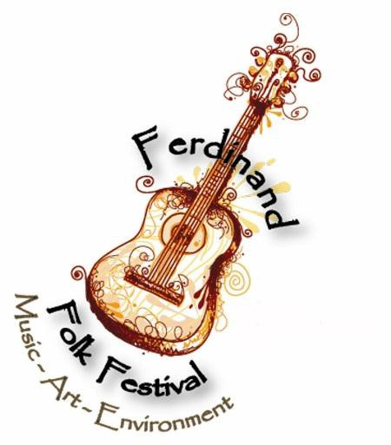

**Vendor/Exhibitor Application**

**Application preferred by Friday, July 29, 2022. The**

**selection process will begin in early April. Applicants will be notified ASAP. If booth is NOT accepted, reservation fees will be returned.**

Name (Please print): Telephone(s):

Address:

Business Name (if applicable):

E-mail Address:

Web site Address (if applicable):

Please check type of 10’ x 10’ booth requested:

Art/Artisan Booth (**$50**) — Please submit required photograph(s) or cd’s;

**they will not be returned.**

Booth (**$55**) — Valid Food License/Permit available upon request

Environmental and Wellness Education Booth (**$20**)

A few double booths (at double the cost) might be available as space and logistics allow.

Would you like to be considered for a double booth (10’ x 20’), if your booth is approved?

yes no

Description of booth contents, food, or materials:

Please write the number of tables (approx. size: 30” x 84” each) that you would like to rent, if your booth is approved:

x $10 each =

X

*incomplete and cannot be accepted)*

*signature (must sign or application is*

Dealer signature required. By signing you agree to all above statements and agree not to hold the Town of Ferdinand, the Ferdinand Chamber of Commerce, and the Dubois County Tourism Commission liable for injury, theft, loss, or illness in conjunction with the show. Dealers will not sell any fraudulent or illegal merchandise; nor will imported or mass-produced goods be allowed. The promoter reserves the right to reject any merchandise at any time during the show. Vendors/exhibitors must be set-up by 11:30 am EDT on Saturday and will not be permitted to tear down before 6:00 pm EDT on Saturday. In the event that vendor must cancel participation, as a courtesy to other artisans on waiting list, please let the promoters know as soon as possible so that the booth spot might be filled. Dealers are responsible for all applicable Indiana state taxes and registration fees.

Please send to **The Town of Ferdinand**,

**Attention: Chris James or** e-mail form (and JPEG or PDF photos if art booth) to

**2065 Main Street** [**cjames@ferdinandindiana.org**](mailto:cjames@ferdinandindiana.org)

**P.O. Box 7**

**Ferdinand, IN 47532**